Bio Image Operation (BIO) user manual

*Introduction*

BIO is a next generation image processing tool focusing on biological applications, balancing ease of use with desired flexibility required for research. This tool has been developed in collaboration with biologists, using extensive captured images. The solution balancing both the need for research purposes and flexibility required for this, and desired ease of use is realised in a script-based user interface. The tool uses the widely used OpenCV for many of its image operations, with an efficient tracking algorithm allowing real time processing.

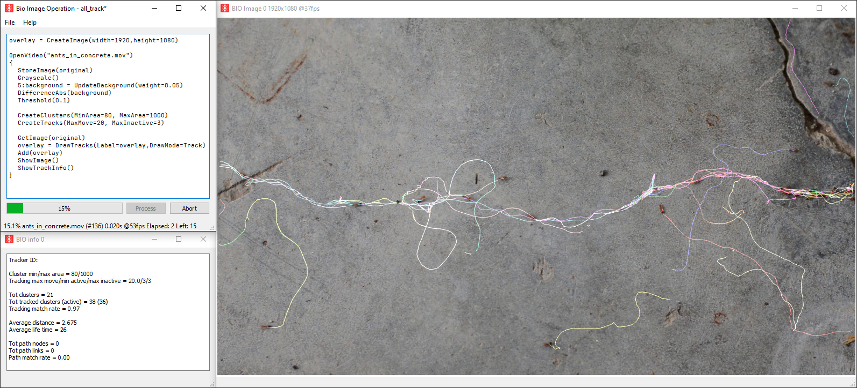

*Requirements*

* OS: Windows 64-bit (coming soon: MacOS, Linux, Pi)

*Installation*

* Download and run binary which will guide the installation process
* Clone and build from source

See Help & Links below for links to binaries and source.

*Quick use*

BIO is operated using a scripting interface. Script files can be loaded and saved in the user interface.

BIO can also be executed from the command line like: BioImageOperation /path/to/script.bioscript

See Help & Links below for links to example scripts.

The starting operations for source images are:

* CreateImage - Create a blank image
* OpenImage - Open a single or series of images (any ffmpeg format)
* OpenVideo - Open a single or series of video files (any ffmpeg video format)
* OpenCapture - Open capturing from video (IP) path or camera source (#)

Series of images or videos should be labelled with a numeric format, wild-card pattern can be used (i.e. OpenImage(“image*.tif”) will read for example image0000.tif, image0001.tif, etc.)

General rules:

* Operations have an optional assignment e.g.: a = Grayscale()
* Any operation is on the current image, unless a source image label is used
* Any operation will replace the current image, unless an assignment is used
* A line can only support one operation (with an optional assignment)
* Use // for comments
* Preceding an operation with a number (x:Operation()) will only execute the operation once every x images
* Preceding an operation with 2 numbers (x-y:Operation()) will only execute the operation once every x images, on offset y

Example script:

OpenVideo("ants_in_concrete.mov") - open video file

{ - start of inner operations (for OpenVideo images)

  Grayscale() - convert to grayscale

  5:background = UpdateBackground() - once every 5 images: update background & assign

  DifferenceAbs(background) - subtract background from current image

  Threshold() - apply binary threshold on current image (using Otsu)

  CreateClusters() - create clusters, automatically define parameters

  CreateTracks() - create tracking, automatically define parameters

  DrawClusters() - draw clusters into current image

  ShowImage() - show current image

} - end of inner operations (for OpenVideo images)

*Help & Links*

* Script help in BioImageOperationScript document or command line: BioImageOperation -help
* Script examples on GitHub (see below)
* Discussion & Support at the community forum at [image.sc](https://image.sc/) using the tag BioImageOperation
* Source code and example scripts: [github.com/folterj/BioImageOperation](https://github.com/folterj/BioImageOperation)
* Binaries and basic script examples: [joostdefolter.info](https://joostdefolter.info)
* Qt: [qt.io](https://qt.io)
* OpenCV: [opencv.org](https://opencv.org)
* Openh264: [github.com/cisco/openh264](https://github.com/cisco/openh264)